Link: <https://www.crackmes.one/crackme/5c8e1a9533c5d4776a837ecf>

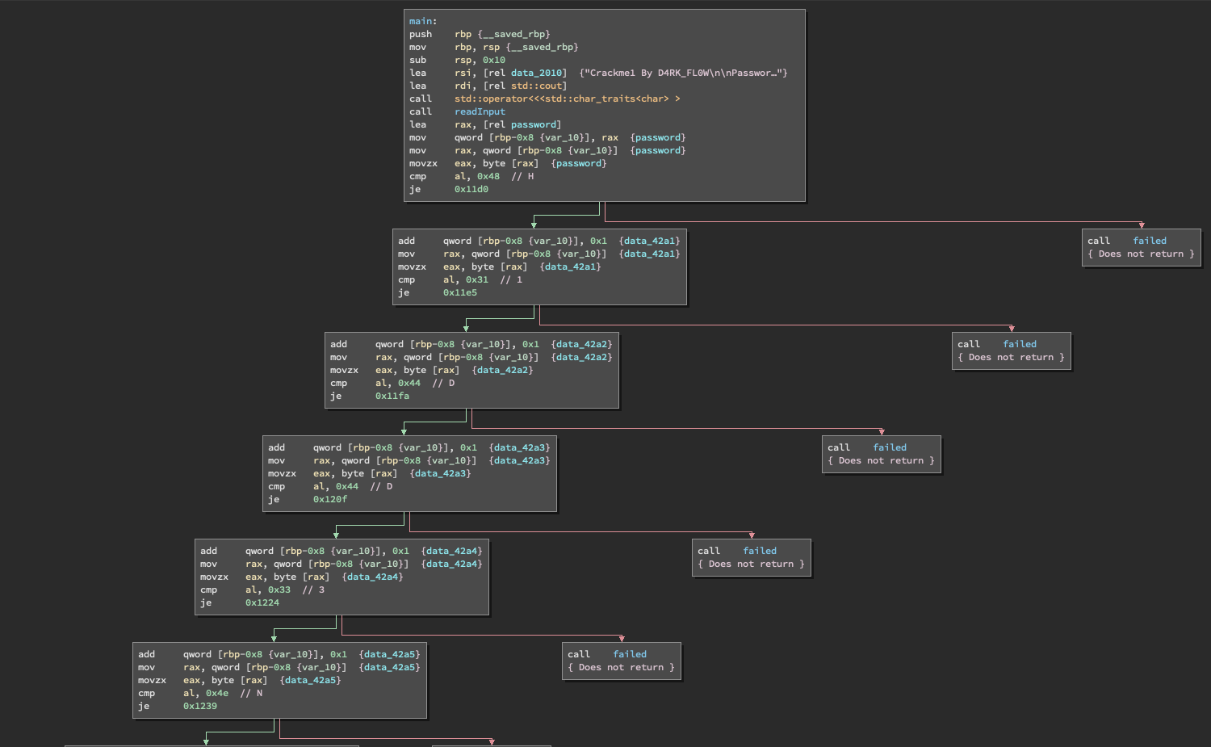The first reverse engineering exercise I’ve undertaken does have a walkthrough so I could learn how reverse engineering works. Looking at the disassembled code we can see there are a set of if statements. Those if statements seem to compare an input for a password letter by letter. The password ends up being “H1DD3N”.